EF Core 8.0 Guided Hands-On Exercises

Lab 4: Inserting Initial Data into the Database

CODE:

using System;

using System.Collections.Generic;

using System.Threading.Tasks;

using Microsoft.EntityFrameworkCore;

namespace UniqueStoreApp

{

// Category model with nullable properties

public class Category

{

public int CategoryId { get; set; }

public string? Name { get; set; } // Made nullable to avoid CS8618

public List<Product>? Products { get; set; } // Made nullable

}

// Product model with nullable properties

public class Product

{

public int ProductId { get; set; }

public string? Name { get; set; } // Made nullable

public decimal Price { get; set; }

public Category? Category { get; set; } // Made nullable

}

// Database context class

public class AppDbContext : DbContext

{

public DbSet<Category> Categories { get; set; }

public DbSet<Product> Products { get; set; }

protected override void OnConfiguring(DbContextOptionsBuilder optionsBuilder)

{

// Use LocalDB connection string

optionsBuilder.UseSqlServer(@"Server=(localdb)\MSSQLLocalDB;Database=UniqueStoreDB;Trusted_Connection=True;");

}

}

// Main application class

class Program

{

static async Task Main(string[] args)

{

using var dbContext = new AppDbContext();

// Create DB if not already created

await dbContext.Database.EnsureCreatedAsync();

// Create categories

var electronics = new Category { Name = "Electronics" };

var groceries = new Category { Name = "Groceries" };

await dbContext.Categories.AddRangeAsync(electronics, groceries);

// Create products

var laptop = new Product { Name = "Laptop", Price = 75000, Category = electronics };

var riceBag = new Product { Name = "Rice Bag", Price = 1200, Category = groceries };

await dbContext.Products.AddRangeAsync(laptop, riceBag);

// Save changes

await dbContext.SaveChangesAsync();

Console.WriteLine(" Data inserted into UniqueStoreDB successfully!");

// Print inserted data

var categories = await dbContext.Categories.Include(c => c.Products).ToListAsync();

Console.WriteLine("\n Listing All Categories and Products:\n");

foreach (var category in categories)

{

Console.WriteLine($" Category: {category.Name}");

if (category.Products != null)

{

foreach (var product in category.Products)

{

Console.WriteLine($" Product: {product.Name}, Price: ₹{product.Price}");

}

}

}

}

}

}

OUTPUT:

Data inserted into UniqueStoreDB successfully!

Listing All Categories and Products:

Category: Electronics

Product: Laptop, Price: ₹75000.00

Category: Groceries

Product: Rice Bag, Price: ₹1200.00

Category: Electronics

Product: Laptop, Price: ₹75000.00

Category: Groceries

Product: Rice Bag, Price: ₹1200.00

Category: Electronics

Product: Laptop, Price: ₹75000.00

Category: Groceries

Product: Rice Bag, Price: ₹1200.00

Category: Electronics

Product: Laptop, Price: ₹75000

Category: Groceries

Product: Rice Bag, Price: ₹1200

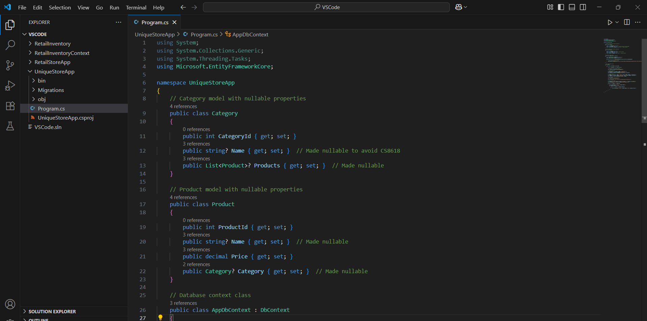ScreenShots:

